You have:
- On-prem SQL Server
- 10 tables total
  - 5 Incremental load
  - 5 Full (fixed) load
- Target: Azure (Azure SQL DB / ADLS / Synapse — pattern is same)

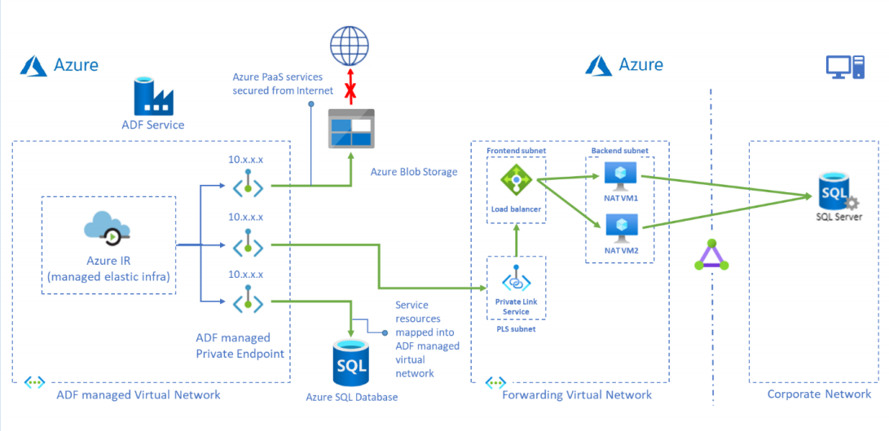
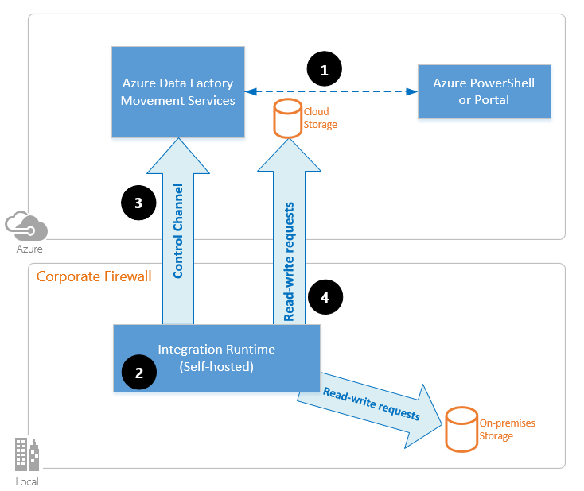
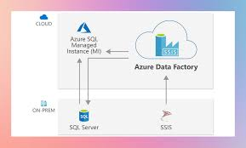
4

Overall Architecture (Very Important)
- On-prem SQL Server
- Self-Hosted Integration Runtime (SHIR) → installed inside your network
- Azure Data Factory
- Target in Azure (Azure SQL DB / ADLS Gen2)

Step 1: Install Self-Hosted Integration Runtime (SHIR)
Because source is on-prem, this is mandatory.
Steps
- Go to Azure Data Factory
- Manage → Integration runtimes → New → Self-Hosted
- Install IR on:
  - SQL Server machine or
  - Any VM that can reach SQL Server
- Register it using the key from ADF
✔ This allows ADF to securely read on-prem data.

Step 2: Create Linked Services
You’ll need 2 linked services.

1️⃣ Source: On-prem SQL Server
- Type: SQL Server
- Integration Runtime: Self-Hosted
- Auth: SQL / Windows
- Test connection ✔

2️⃣ Sink: Azure
Examples:
- Azure SQL Database
- ADLS Gen2
- Synapse

Step 3: Dataset Creation
Create datasets for:
- Each source table (or parameterized dataset)
- Each target table
👉 Best practice: Parameterized datasets
Example parameters:
- schema_name
- table_name

Step 4: Fixed (Full) Load – 5 Tables
These tables are always fully refreshed.

Pipeline Logic
For each table:
Source SQL → Truncate Target → Copy Activity

Source Query
SELECT * FROM dbo.fixed_table_1

Sink Settings
- Pre-copy script:
TRUNCATE TABLE dbo.fixed_table_1;
✔ Use ForEach activity if 5 tables have same pattern.

Step 5: Incremental Load – 5 Tables
These load only new / changed data.
You need one of these columns:
- last_updated_date
- created_date
- identity / sequence
- rowversion

Step 5.1: Create Watermark Table (Control Table)
In Azure SQL (or metadata DB):
CREATE TABLE watermark_control (
table_name VARCHAR(100),
last_watermark DATETIME
);

Step 5.2: Incremental Source Query
SELECT *
FROM dbo.incremental_table_1
WHERE last_updated_date > @watermark
Watermark value comes from control table.

Step 5.3: Pipeline Flow (Incremental)
- Lookup → get last watermark
- Copy Activity → load delta data
- Stored Procedure / Script → update watermark
UPDATE watermark_control
SET last_watermark = GETDATE()
WHERE table_name = 'incremental_table_1';

Step 6: Combine Both in One Pipeline (Best Practice)
Use metadata-driven pipeline.

Control Table Example
table_name | load_type | watermark_column
-----------------------------------------
orders | INCR | last_updated
products | FULL | NULL

Logic
- Lookup control table
- ForEach table
  - If load_type = FULL → full copy
  - If load_type = INCR → incremental logic
✔ This avoids 10 separate pipelines.

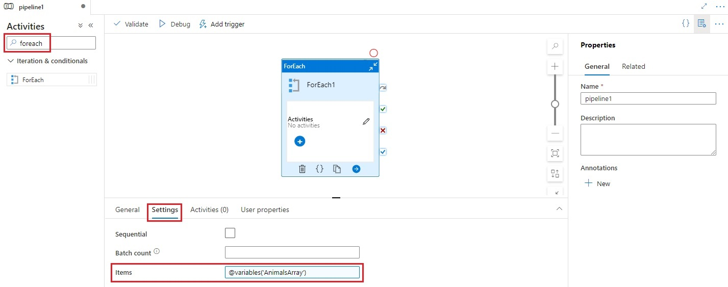
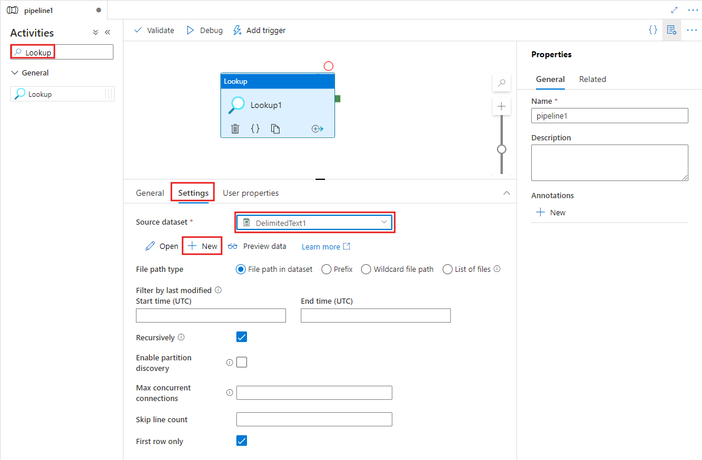
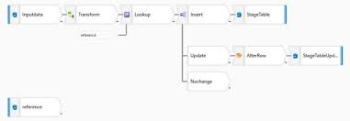

Step 7: Scheduling & Monitoring
- Trigger: Schedule (daily/hourly)
- Enable:
  - Retry
  - Failure alerts
- Monitor → Pipeline runs

Real-World Tips (Very Important)
✔ Keep incremental tables indexed on watermark column
✔ Never do incremental without control table
✔ Use batch size for large tables
✔ Separate schema changes handling
✔ Log row counts (source vs target)

Simple Summary
- Fixed load (5 tables) → Truncate + Full Copy
- Incremental load (5 tables) → Watermark + Delta Copy
- SHIR is mandatory
- Metadata-driven pipeline is best

